Subject line: 4 Tips for Self-Improvement
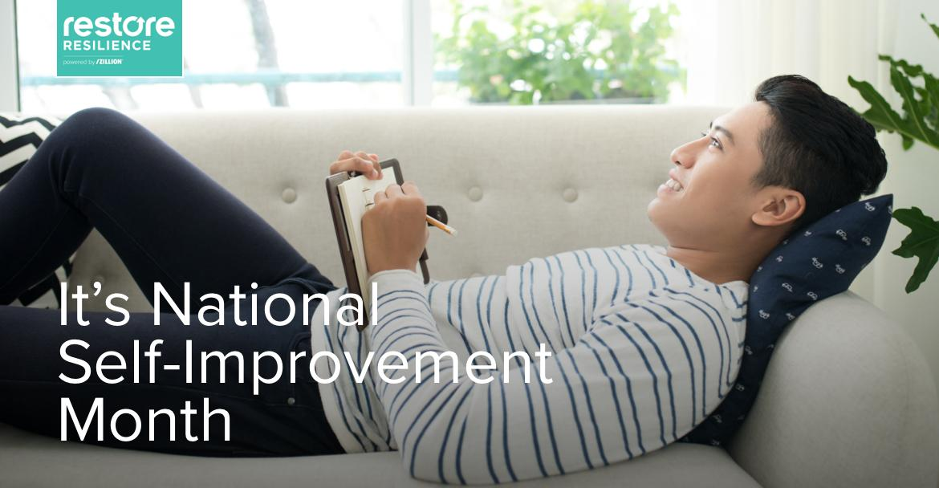

Dear [Employee],
September is National Self-Improvement Month, and we want to celebrate it with you. The holiday is all about pushing yourself a little farther to be the person you’ve always wanted to be. Reflect on your personal journey: is there an aspect you want to improve – physical, mental, emotional?

Our mental health and wellness benefit, RestoreResilience, created a flyer with 4 tips for pursuing self-improvement which you can view in the attached flyer.

Sign up for RestoreResilience for FREE to learn to create healthy habits, be more mindful, build relationships, and better cope with stress.

Use group ID “thestandardresilience” during enrollment.

Best,
The [COMPANY] Team

Secure and confidential: The RestoreResilience program is delivered on a highly secure, HIPAA-compliant platform and therefore all personal health information (PHI) will remain safe and confidential. Additionally, since Zillion is a 3rd-party solution provider, participation within the program is also confidential and no information will be accessible by your health insurance provider.

